SP LAB 5



Submitted by: **ALI ASGHAR** Registration No: **21PWCSE2059**

Section: **C**

Submitted to:

**Engr. Abdullah Hamid**

“On my honor , as student of University of Engineering and Technology, I have neither given nor received unauthorized assistance on this academic work”

Department of Computer Systems Engineering

University of Engineering and Technology Peshawar

task1;

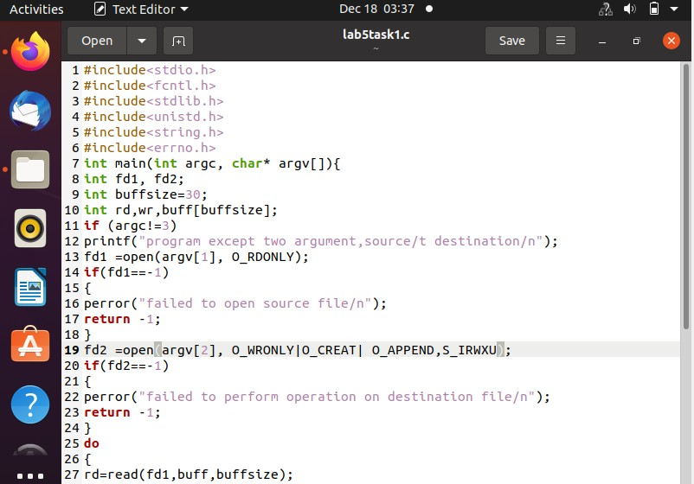

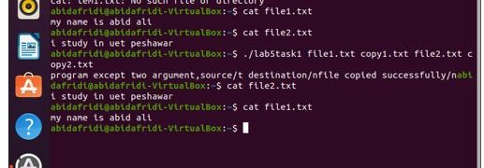

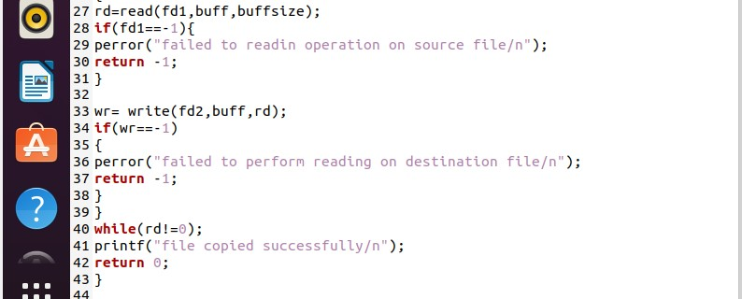

Task2;

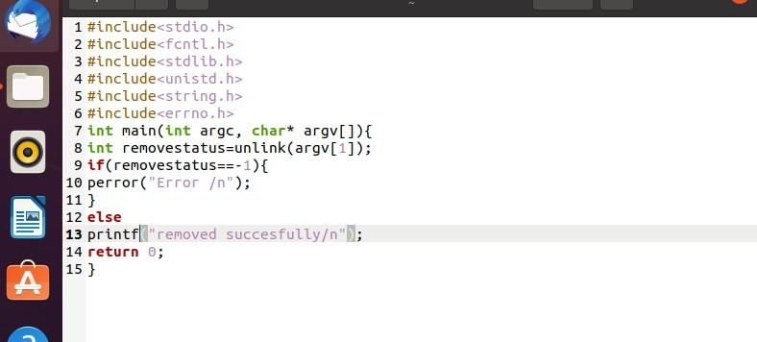

Out put:

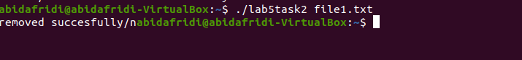

Task3;

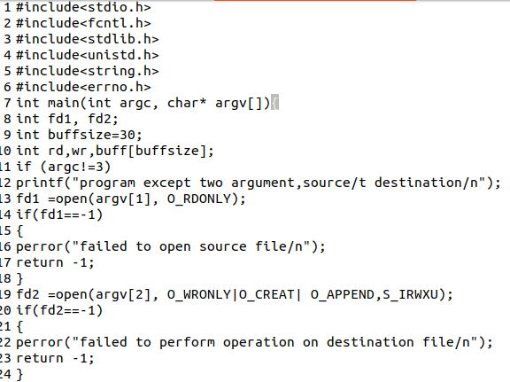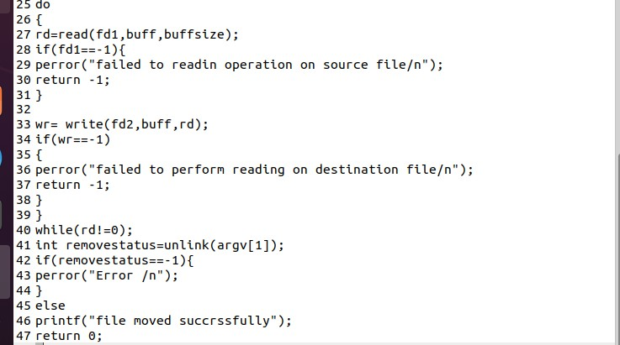

Out Put:

